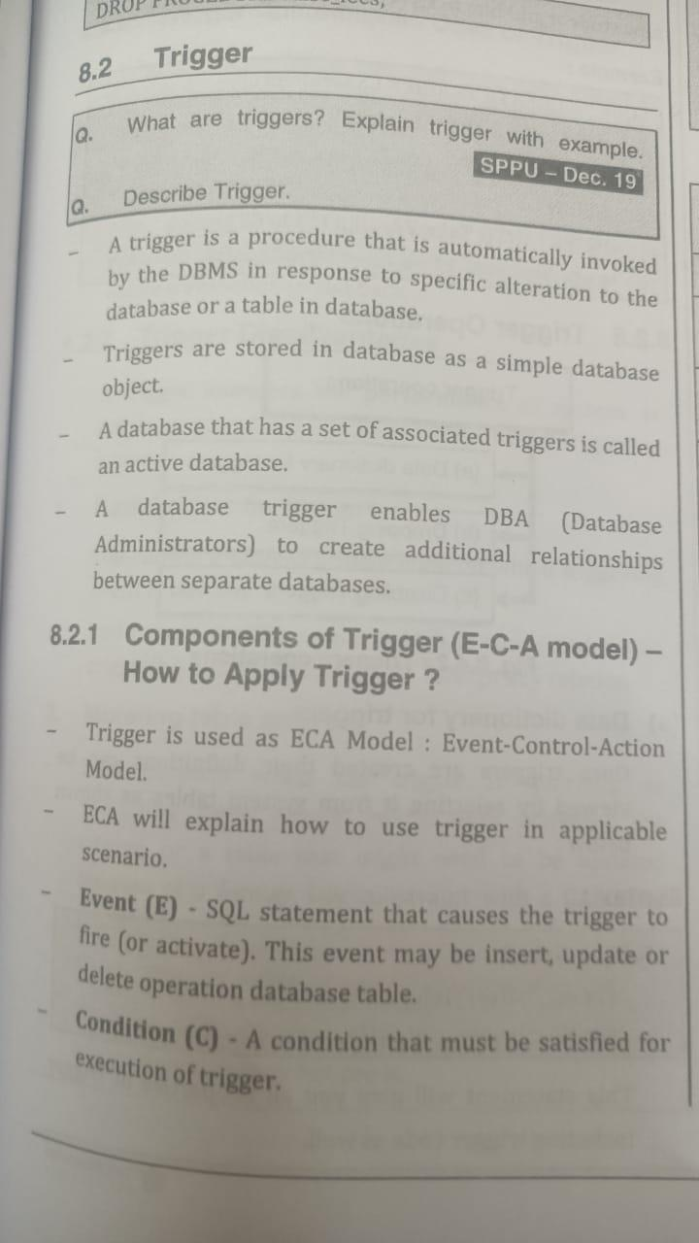

A **trigger is called a special procedure** because it cannot be called directly like a stored procedure. The key distinction between the trigger and procedure is that a trigger is called automatically when a data modification event occurs against a table. A stored procedure, on the other hand, must be invoked directly.

The following are the main characteristics that distinguish triggers from stored procedures:

* We cannot manually execute/invoked triggers.
* Triggers have no chance of receiving parameters.
* A transaction cannot be committed or rolled back inside a trigger.

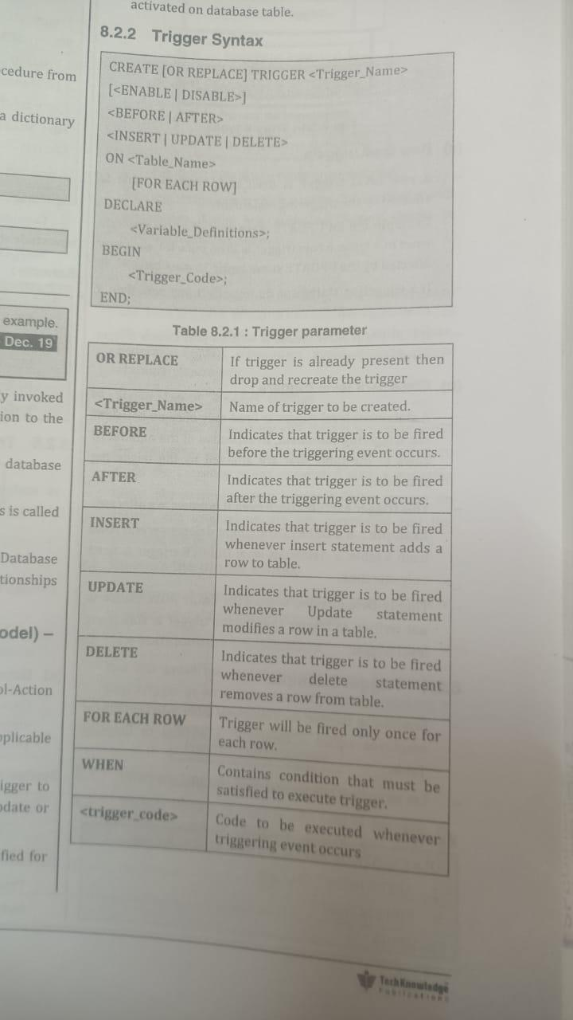

delimiter $$

drop trigger if exists facultydata1 $$

create trigger facultydata1

before insert on faculty for each row

begin

insert into faculty_backup set action='insert',new_id=new.id,date=now();

end $$

delimiter ;

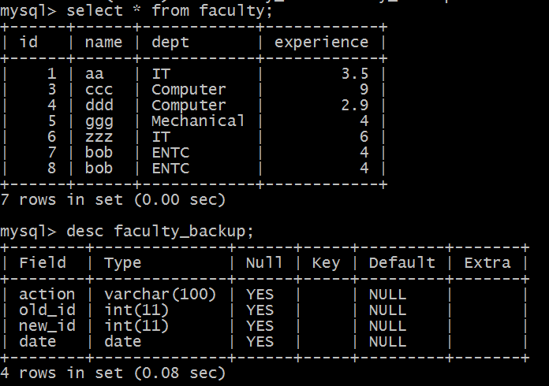

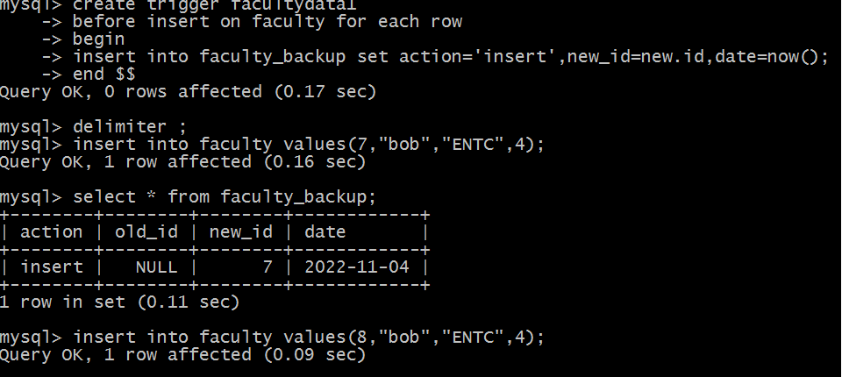

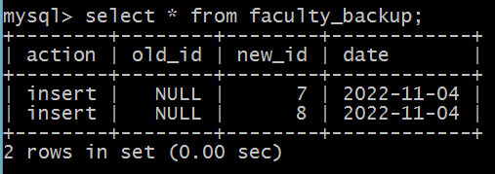

delimiter $$

drop trigger if exists facultydata2 $$

create trigger facultydata2

before delete on faculty for each row

begin

insert into faculty_backup set action='delete',old_id=old.id,date=now();

end $$

delimiter ;

